## [What is HEAD in Git?](https://stackoverflow.com/questions/2304087/what-is-head-in-git) What is ‘Detached Head’?

<https://www.youtube.com/watch?v=ZaI1co-rt9I>

<https://stackoverflow.com/questions/2304087/what-is-head-in-git>

Head is usually a reference to the most recent commit in current branch.

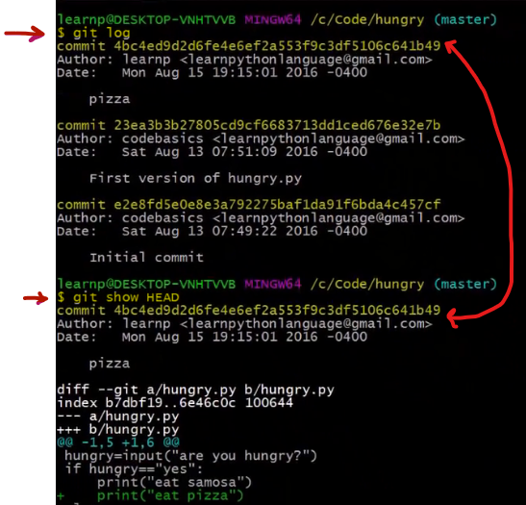

Note that we can use HEAD to refer to the most recent commit, and use HEAD~ as the commit before the tip, and HEAD~~ or HEAD~2 as the commit even earlier, and so forth.

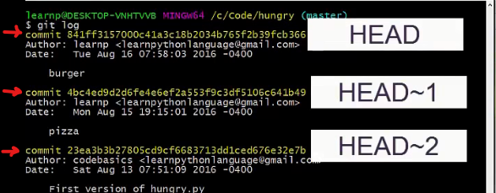

HEAD can point to any commit, it does not need to be the last commit in any branch. (When HEAD points to a commit that is not the last commit in a branch, that is a "detached HEAD"

